**Name: Olawumi Abayomi Ebenezer**

**Matric Number: EEE/12/9579**

**Chapter 9**

1. Yes, tuple can be passed as an argument to a function. In the example below, the tuple was passed into the function and the third element was printed inside the function. Hence, the assertion.

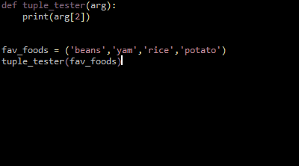

Output:

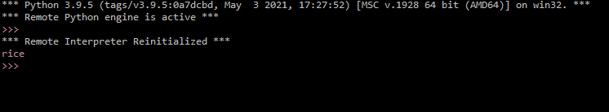

1. Pair is a generalization of tuple, Tuple is not a generalization of pair
2. Pair is a kind of tuple